May 13, 2025

**Alamut Talent**

**Management (ATM)**

**A L A M U T T A L E N T M A N A G E M E N T**

**From Mountains to Mainstream**

+923443444431



Pha D Type Apartment G11/4 Islamabad

[www.aalamut.com](http://www.aalamut.com/)

May 13, 2025

# About Our Company

**A L A M U T T A L E N T M A N A G E M E N T**

Alamut Talent Management (ATM) was born out of a deep concern for the growing vulnerabilities faced by digital influencers—especially young creators from underserved regions like Gilgit-Baltistan and Chitral. After witnessing cases of exploitation, harassment, and privacy breaches, we set out to create a safe, empowering space where influencers can thrive without fear.



ATM is a purpose-driven tech startup pioneering the future of influencer marketing through a secure, AI-powered platform that connects influencers and brands transparently. Our solution enables both sides to collaborate efficiently, track performance in real-time, and ensure fair compensation—removing the need for unsafe middlemen and opaque deals.

Founded by local experts passionate about digital literacy, impact, and ethical tech, ATM is starting its journey in Northern Pakistan, with a vision to scale nationally and globally. We're not just building a platform; we're building a movement to redefine how digital influence works—safely, smartly, and sustainably.

May 13, 2025

**Problem**

**A L A M U T T A L E N T M A N A G E M E N T**

While Pakistan’s digital landscape is expanding rapidly, influencers from remote and underserved areas like Gilgit-Baltistan and Chitral remain largely unsupported. These emerging voices, often from minority communities, face serious challenges—ranging from lack of digital literacy and professional guidance to exploitation and security breaches. Despite their growing online presence, there is no dedicated platform that protects their rights, ensures ethical collaborations, or helps brands connect with them in a safe, structured way.



Underserved Talent Security Risks

Brand Challenges Platform Gap

May 13, 2025



**Solution**

Alamut Talent Management (ATM) is building a purpose-driven digital platform that bridges the trust and access gap between influencers and brands. Focused initially on regions like Gilgit- Baltistan and Chitral, ATM creates a secure, transparent space where creators can grow without fear, and brands can engage without risk. By integrating verification systems, performance insights, and ethical compensation models, ATM ensures that every collaboration is built on clarity, accountability, and mutual growth.

#### Trusted & Safe Community

Every influencer and brand undergoes a vetting process— creating a protected environment for authentic, respectful collaboration.

### Ethical Earning Model

Compensation is transparent and merit- based, ensuring influencers are rewarded fairly for their reach and engagement.

**A L A M U T T A L E N T M A N A G E M E N T**

### Insight-Driven Growth

Built-in analytics empower creators and brands to understand impact, improve strategies, and make data-informed decisions.

#### Purpose-Built Scalability

While rooted in underserved regions, the platform is designed to grow nationally and globally—amplifying voices that often go unheard.

May 13, 2025

# Product Overview

**For Influencers**

**A L A M U T T A L E N T M A N A G E M E N T**

##### Alamut Talent Management (ATM) is Pakistan’s first purpose-built influencer marketing platform designed to bridge the trust gap between emerging influencers and forward-looking brands. By offering tailored digital environments for both influencers and brands, ATM brings structure, clarity, and accountability to a fast- growing but fragmented space—starting from the margins of Gilgit-Baltistan and Chitral, and scaling across the nation.

Whether it’s a small business seeking reach or a young content creator navigating digital income for the first time, ATM is building the rails for secure, impact-driven influencer commerce.

A dedicated space to grow, earn, and stay in control.

**Verified Sign-Up**

**Campaign Dashboard**

**Earnings & Commission Tracker**

**Profile & Performance Insights**

Secure Messaging & Notifications

**For Brands**

A smarter way to activate influencer-led campaigns with data at the core.

Campaign Management Hub

Influencer Discovery Tool

Historical Campaign Data

Payment Transparency



Performance Metrics (ROI, ROS, COGS, EBITA)

May 13, 2025

**Market Size**

##### The influencer marketing economy in Pakistan is rapidly growing, yet remains largely untapped in

**Total**

**Market Breakdown**

**Serviceable**

**A L A M U T T A L E N T M A N A G E M E N T**

**Serviceable**

##### underserved regions like Gilgit- Baltistan and Chitral. With over 12 million active social media users aged 18-35 in Pakistan, and an estimated 250,000+ content creators, the need for structured, safe, and scalable influencer-brand collaboration is urgent. Alamut Talent Management (ATM) is uniquely positioned to become the go-to platform in this emerging landscape—starting with regional hubs and scaling nationally and globally.



**Addressable**

**Market (TAM)**

$300M+

Estimated size of influencer marketing spend in Pakistan by 2026

**Available Market**

**(SAM)**

Spending by mid-sized brands and regional businesses looking for local influencer activation (esp.

Tier 2/3 cities)

**Obtainable Market**

**(SOM)**

Initial reachable market within the first 3 years

—focused on Gilgit-Baltistan, Chitral, and Northern Pakistan

May 13, 2025

**Market Breakdown**

**A L A M U T T A L E N T M A N A G E M E N T**



**Why Now?**

|  |  |  |
| --- | --- | --- |
| **Target Influencer Base (Year 1–3)** | | |
| **Region Estimated Engagement Level Influencers** | | |
|  |  |  |
|  |  |  |
|  |  |  |
|  |  |  |
|  |  |  |
|  |  |  |

High smartphone penetration even in remote areas

Gilgit-Baltistan

Chitral

Rest of Pakistan

Total Influencers Worldwide

Active Content Creators Monetizing Content

Global Market Value

5,000–7,000

2,000–3,000

250,000+

>300 million

~50 million

$24–28 billion

Medium to High

Growing rapidly 10–15% monetized

Includes all levels: nano, micro, macro,

and celebrity influencers

Across YouTube, TikTok, Instagram, Twitch, etc.

Global influencer marketing industry valuation (source: Influencer Marketing Hub 2024)

TikTok, YouTube Shorts & Instagram Reels enabling rural creators to go viral overnight

Brands seeking micro-influencers for authentic regional storytelling

Lack of regulation or structured support leaves creators vulnerable

May 13, 2025

**SWOT ANALYSIS**

**A L A M U T T A L E N T M A N A G E M E N T**

Innovative Solution: Unique approach to a key market problem.

Experienced Founders: Strong local market knowledge.

**s**

First-Mover Advantage: Capture market share in Gilgit-Baltistan first.

Tech Integration: AI-driven platform with advanced analytics.

Brand Recognition: New business with

no established presence.

Unproven Demand: Market acceptance yet to be validated.

**W**

Resource Constraints: Bootstrapped funding limits growth speed.

Operational Risks: Scaling and managing growth challenges.

Growing Demand: Rising need for AI- powered influencer marketing.

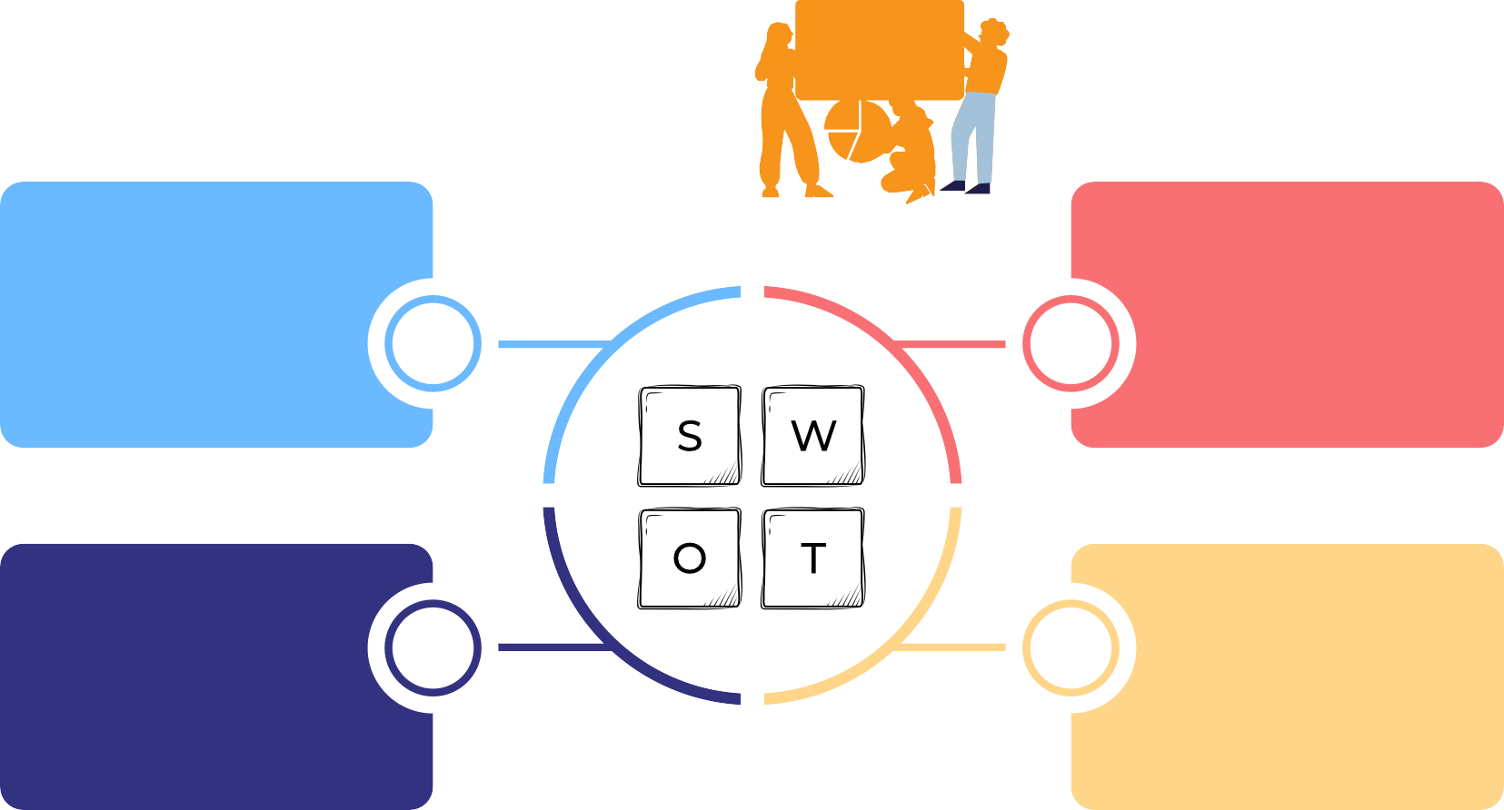

**O T**

Expansion: Scale from Gilgit-Baltistan to global markets.

Strategic Partnerships: Collaborate with brands and influencers.

Revenue Streams: Multiple income sources including subscriptions.

Market Trends: Popularity of digital marketing and AI integration.

Competition: New entrants and big players may replicate model.

Economic Downturn: May reduce brand spending on marketing.

Regulatory Risks: Evolving influencer

marketing regulations.

Adoption Hurdles: Convincing brands to integrate may take time.

May 13, 2025

## Business Model : Alamut Talent Management (ATM)

Revenue Streams:

**A L A M U T T A L E N T M A N A G E M E N T**

**Performance-Based Revenue Share**



**Influencer Earnings:**

ATM takes a

commission from the revenue earned by influencers through product promotions.

**Commission Range:** Typically between 5% to 20%, depending on the on the product category and campaign specifics

**Subscription Fees for Brands**

**Monthly/Annual Subscriptions:**

Brands pay a recurring fee to maintain their presence on the platform.

**Pricing Tiers**: Different subscription levels based on features and access.

**Campaign Management Fees**

**Setup and**

**Management**: ATM charges brands for the setup and management of influencer campaigns.

**Fee Structure:** Can be a flat fee or a percentage of the campaign budget.

**Premium Analytics and Reporting**

**Advanced Insights:**

Brands can access detailed analytics and performance reports for a fee.

**Custom Reports:** Tailored insights to optimize future campaigns.

**For Influencers:** A secure platform offering fair compensation, transparent tracking, and growth opportunities.

**For Brands**: Access to a curated network of influencers, data-driven campaign management, and measurable ROI.

**Value Proposition**

**Target Audience:** Influencers from Gilgit-Baltistan and Chitral, with plans for national and global expansion.

**Market Positioning**

**Competitive Edge:** Combining AI- driven matching, secure ecosystem, and performance-based monetization.

May 13, 2025

## Digital Payment Model: Transparent, Inclusive, and Timely

**Empowering Influencers and Brands through Seamless Digital Transactions**

Alamut Talent Management (ATM) integrates Pakistan’s national Raast instant payment system into its platform to ensure secure, transparent, and real-time transactions.

**A L A M U T T A L E N T M A N A G E M E N T**



**Key Features of Our Digital Payment Model**

**Financial Inclusion for Underserved Creators**

###### Brings young influencers— particularly women and minorities in remote regions— into the formal financial ecosystem.

**Transparency & Accountability**

###### Every payment is logged within the ATM dashboard, enabling both parties to track earnings and expenses in real time.

**Timely Payments**

###### Ensures influencers are compensated promptly upon campaign milestones, building trust and professionalism.

**Ease of Use**

###### Simple onboarding process for influencers and brands to link their Raast- enabled accounts.

May 13, 2025

**Our Team**

**A L A M U T T A L E N T M A N A G E M E N T**



Sami Ullah Baig

**C0 - FOUDNER**

Asim Baig

Sami Ullah Baig is a seasoned communications strategist and development consultant with over 7 years of cross-sector experience spanning fintech, development, and corporate branding. Originally from Hunza, Gilgit-Baltistan, Sami has led national-level outreach and financial literacy campaigns, including projects funded by the State Bank of Pakistan. His professional journey includes key roles at organizations like Rupani Foundation, Pakistan Alliance for Early Childhood, and Bangla Tigers, where he led large-scale communication, market development, and investment facilitation initiatives. With a strong understanding of stakeholder engagement, digital outreach, and regional market dynamics, Sami brings a unique mix of grassroots insight and strategic leadership—making him a driving force behind inclusive financial solutions like this ATM network.

Asim Baig is a growth and partnerships expert with over 6 years of experience in retail, FMCG, and tech startups. A LUMS graduate and former sales operations lead at Nestlé Pakistan, Asim has driven multimillion-rupee revenue growth, scaled new city launches, and led nationwide customer acquisition and retention strategies. From optimizing affiliate networks at VYRO LLC to managing exclusive distributor networks at Retailo, he has consistently delivered data-driven results. With deep insights into sales operations, strategic partnerships, and tech-enabled retail models, Asim brings analytical rigor and executional strength to the ATM venture—ensuring its scalability, profitability, and operational excellence.

**C0 - FOUDNER**

**Thank You**

Questions Please!

**A L A M U T T A L E N T M A N A G E M E N T**

+923443444431



Pha D Type Apartment G11/4 Islamabad

[www.aalamut.com](http://www.aalamut.com/)